- SCOPE:
  - The intent of this procedure is to define the method for communicating, resolving, and documenting various types of supplier concerns and the process for evaluating the effectiveness and efficiency of the actions taken; including cost tracking and formal resolution. (Quality, Logistic, Warranty and PPAP)
  - This procedure applies to corrective actions in response to supplier non-conformance and customer concerns if affected as well as actions taken to prevent the repeat of non- conformances.
  - This procedure applies to all external suppliers of TI Fluid Systems (TIFS) including customer directed suppliers. This is a global procedure and applies to all Divisions of TIFS.
- RESPONSIBILITIES:
  - The Process Owner is the Global Corporate Purchasing Director.
  - All TIFS personnel initiating supplier concerns are responsible to ensure that it is communicated to the appropriate Manager or designee.
  - The Regional Division Leaders or designees are responsible for monitoring the closure of the corrective action activity according to the requirements of this procedure.
  - The Quality Manager / or designee is responsible for managing supplier quality concerns, coordinating corrective actions, timely communication from the supplier/affected personnel and maintenance of records and correspondence logs related to supplier concerns. In the event the supplier concern affects a TIFS Customer; the Quality Manager will be responsible for managing the customer concern.
  - The Materials / Logistics Manager / or designee is responsible for managing supplier logistic concerns, coordinating corrective actions, timely communication from the supplier/affected personnel and maintenance of records and correspondence logs related to supplier concerns. In the event the supplier concern affects a TIFS Customer; the Quality Manager will also be responsible for managing the customer concern
  - The Warranty Manager / or designee is responsible for managing supplier warranty concerns, coordinating corrective actions, timely communication from the supplier/affected personnel and maintenance of records and correspondence logs related to supplier concerns. In the event the supplier concern affects a TIFS Customer; the Quality Manager will also be responsible for managing the customer concern.
  - Purchasing and Plant Quality are responsible for managing supplier PPAP concerns, coordinating corrective actions, timely communicating and correspondence from the supplier/affected personnel and maintenance of records and correspondence logs related to supplier concerns. In the event the supplier concern affects a TIFS Customer, the Quality Manager will also be responsible for managing the customer concern. PPAP is the final document of supplier AQP process and concerns must be covered within supplier AQP.
  - The Plant/General Manager, Purchasing, Quality Manager & Supplier Quality are responsible for ensuring appropriate resources and support is provided for effective corrective action resolution, implementation, and verification.
  - It is the responsibility of Quality Managers, Purchasing Managers, Logistics Managers with support from Supplier Quality to ensure corrective actions are implemented in response to nonconformities found or Supplier Non-Conformance Reports (SNCR’s) issued by TIFS to one of our suppliers.
  - Regional Purchasing, Regional Supplier Quality, Regional Quality and Engineering is responsible for supporting the plants when appropriate, including interfacing with the supplier and if required, the customer on high risk issues.
- DEFINITIONS:
  - Abbreviations
Abbreviation | Signification
AIAG | Automotive Industry Action Group
APQP | Advanced Product Quality Planning
CAR | Corrective Action Report by an audit finding (internal or external)
COPQ | Cost of Poor Quality
CSCC | Customer Safety or Critical Concern
DOE | Design of Experiment
FACT | Field Action Concern Team
FMEA | Failure Mode Effects Analysis
GQPS | Global Quality Performance System
ODT | On time delivery
PPAP | Production Part Approval Process
Ipb | Incidents Per Billion
8D / PPS | 8 Dicipline / Practical Problem Solving methodology
RPN | Risk Priority Number
SNCR | Supplier Non-Conformance Report
TIPDB | TI Purchasing Data Base

  - NCR Concerns / Quality Concerns
    - Corrective Action - action taken to detect and eliminate the cause of non-conformity or other undesirable situation to prevent escape and repeat issues.
    - Formal Concern - Any SNCR that is formally documented by a TIFS User Plant and where formal corrective action is requested.
    - Critical Concern - Some formal concerns are considered critical when an impact on risk related to product safety, liability/reliability, design, environment, customer designated high severity, customer sanction and/or field action/warranty and are classified based on field and TIFS internal impact table below:
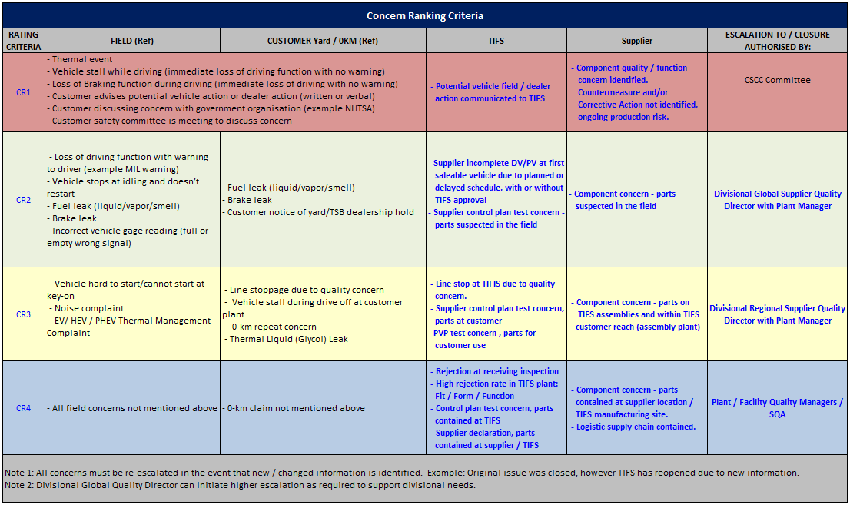
    - Informal Concern - A potential concern voiced by a TIFS User plant that is not formally documented or not included in a SNCR. Informal or potential concerns are typically verbally communicated from a TIFS user plant, or documented during supplier visits by TIFS personnel. Informal concerns must be addressed as a way to drive preventive actions and continual improvements.
  - Delivery Concerns
    - Standard Delivery Concern- a standard delivery concern occurs when the supplier does not have the required quantity at the TIFS facility on the target date it is due. This can be under ship, over ship, late or early shipments.
    - Ex-Works Delivery Concern - an ex-works delivery concern occurs when a supplier does not have the required quantity on the dock ready for shipment at their facility on the target date it is due. This can be under ship, over ship, late/ early shipments.
    - Consignment Delivery Concern - a consignment delivery concern occurs when the supplier fails to maintain the inventory level within the target limits as agreed upon with the TIFS facility. This can be the inventory going below the minimum inventory target or above the maximum inventory target.
  - Warranty Concerns
    - Supplier Warranty Concerns - occur when there is evidence a field issue exists after zero kilometers that is determined via product and data analysis to be caused by a supplier to TIFS. These concerns can be either due to a design problem when the supplier is responsible for the design or a manufacturing problem when it is due to a problem related to the supplier manufacturing process.
  - PPAP Concerns
- Late PPAP Submission - The supplier has not provided all the required information for approval on the date it is due. This can be all of the PPAP information or sections of the PPAP information required by TIFS.
- Incorrect PPAP Information - occurs when the supplier provides evidence or information in at least one of the PPAP sections that does not meet the requirements for TIFS (Right first time) it can include data errors, missing information and information that shows non-compliance where the supplier does not have a written waiver from TIFS.
- Report Format – The TI standard for documenting supplier corrective actions is the 8D Problem Solving methodology. Similar formats that provide the same evidence and information can be utilized with approval from the TIFS user Plant Quality Manager.
- REFERENCES / ASSOCIATED DOCUMENTS:
  - CP-8-ALL-40 Purchasing and Supplier Management Process
  - GP-8-ALL-1 Global Purchasing Policy
  - CP-8-ALL-41 Global Supplier Requirements Manual
  - CP-8-ALL-80 Supplier Escalation Procedure

- PROCEDURE DESCRIPTION:
- Corrective Action - Each TIFS location will implement an effective corrective action process for resolving supplier concerns. This process shall at a minimum follow the steps outlined within the 8D process; briefly defined in 6.0 of this procedure, unless Customer mandated formats are required. The Manager that is responsible for the type of supplier concern being managed (See section 2.0) shall ensure that:
    - An appropriate champion is identified to lead the corrective action process, the associated team and act as the key contact with the supplier.
    - The Corrective Action Team is supported by the appropriate personnel required to ensure completion of the analysis and verify the effectiveness of supplier corrective actions.
    - The effectiveness of the actions taken within the corrective action process is continually evaluated through regular review meetings. The effectiveness of containment steps, interim actions, root cause analysis, permanent corrective actions, systemic corrective actions and lessons learned/read across actions will form the basis of this review.
    - The SNCR is formally closed, with supplier verification and TIFS concurrence.
    - The Corrective Action documentation is properly archived and recorded. The recommended retention time for Corrective Action / Customer Concern documentation is 3 years minimum; unless otherwise specified.
- Supplier Concern Handling
Any TIFS employee who initiates a supplier concern should complete the appropriate sections within the Global Quality Performance System (GQPS) and immediately distribute by e-mail notification, facsimile or telephone to the supplier and applicable TI Department Managers that may be affected by the concern. The Global Supplier Requirements Manual (GSRM) includes requirements for supplier response and TIFS staff must make sure the information is input into the database for accurate tracking. Response time may be used as an input to the supplier performance rating.
As written in the Global Supplier Requirements Manual, any supplier concerns initiated should follow this response timeline:
    - First 4 hours: Receipt of the concern verified by the supplier
    - First 24 hours: Complete the first three steps of the corrective action report which includes containment of product @ supply base, in transit inbound, in house, in transit outbound, in storage, @ customer) and send to the customer. Follow up with a phone call to verify from the supplier to ensure the TIFS user plant has received all of the information and are satisfied.
    - Within 14 days: A root cause analysis and at least a plan for permanent corrective action from the supplier.
    - Supplier correspondence will be maintained to support the Problem Solving Document at each facility which contains the date and time that all updates are forwarded to the TIFS user plant. It is recommended that verbal phone calls are made with each key supplier contact at the time updates are forwarded, and also recorded on the Problem Solving Document.
- Critical Customer Concern Response
The Regional Quality Director and the Global Director of Quality shall be notified for all critical concerns relating to supplier product under any of the following circumstances:
    - The Customer is significantly upset regarding the concern or the Customer Plant Manager is personally involved with the issue.
    - Purchasing personnel at a customer will or have been involved.
    - A stop shipment (finished vehicles on hold) or recall will or could occur.
    - A serious inter-company and/or external rejection has occurred i.e. product performance failure – fuel leakage, repeat concern, containment breech with potential for the initiation of controlled shipping, launch issue, or, potential customer sanction.
    - A significant warranty spike is identified.
    - Failure of key performance testing at any TIFS location that could be an indicator of potential failure modes in the field.
    - Critical customer/supplier issues must be properly communicated to senior management within the supplier location and within TIFS. Suppliers are responsible for ensuring the fast, accurate and appropriate flow of information.
- Rescinding Supplier Concerns
Upon investigation by the Plant Quality Manager or designee, or receipt of evidence from the supplier as proof the concern is not valid, the Plant Quality Manager or designee should contact the supplier and notify them the concern has been rescinded. Documentation of the "rescinded" concern should be recorded in the GQP database and a notice forwarded from the TIFS user plant to the supplier showing the concern deleted or rescinded. If the concern is not rescinded then it will be handled as a valid concern and all actions will be entered into the Supplier Concerns Section of the Global Quality Performance Database. All Appropriate internal and supplier personnel will be notified if a concern is rescinded and the concern database will be updated accordingly.
- Lessons Learned
Suppliers and TIFS will apply the lessons learned and best practices to process and products that are similar to eliminate the cause of the non-conformity. The final steps within the Corrective Action Process, combined with verification that the problem does not exist in any other products/processes are intended to:
- Evaluate the effectiveness of the implemented corrective actions / countermeasures to eliminate repeat issues.
- Analyze and prevent similar issues occurring on other platforms, and production lines for all supplier and TIFS locations.
- Communicate and contain potential issues to all TIFS locations globally through Global Quality Alerts. Verify suppliers have notified any other plant in their company that could also have this concern.
- Upgrade Technical Standards. (If applicable; and if the standard does not exist; create a new standard)
- Verify APQP documents such as the PFMEA and Control Plan have been properly updated regarding the failure mode and RPN.
- Mistake Proofing
TIFS utilizes mistake proofing methodology and expects suppliers to do the same.

- Returned Product Test Analysis
TIFS expects suppliers to analyze all products returned by TIFS facilities. This analysis will be performed in a timely manner and results reported to TIFS; with records kept on file. The cycle time for analysis is dependent on the determination of root cause, corrective action and effectiveness.
- Incidents per Billion (IpB)
TIFS will use information gathered during the corrective action process to calculate and report supplier quality performance; using Incidents per Billion (IpB) as one of the key performance indicators. Supplier IpB will be calculated as follows:

Supplier IpB = (Incident Quantity / Total Receipts) x 1,000,000,000
Definitions:
    - Incident: The cumulative Quality / Warranty / Logistic issue that impacts TIFS or one of their customers resulting in formal complaints irrespective of complaint quantity within a reporting month.
    - Incident weighting: Based on the table in section 3.2.3 and on commodity classification a factor is applied to each incident based on its rating and disruption to TIFS operations.
    - Concern Ranking impact table:
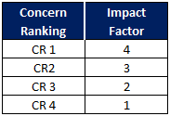
Example:
For a commodity 3 concern with a ranking of 3:
Incident Weighting = Impact Factor x Commodity Class x Concern Qty
6 IpB = 2 x 3 x 1, or
12 IpB for a repeat concern or higher if the repeat results in a higher CR level.
    - Receipts: The total amount of parts received by a TIFS location from a supplier during the reporting month.
    - IpB will be reported as a monthly and rolling 3 month basis and also as a Year To Date value; which will be key indicators used for reporting supplier performance.
    - Only formal / formal critical incidents will be used for calculating IpB
- Cost Recovery
All suppliers will be responsible for any costs associated with the concern they caused. TIFS will clearly document all costs associated with the concern and provide the details and the cost information to the supplier. Only actual costs and the costs for administration of these concerns will be included. The administration costs will be the fair cost for TIFS to manage the concern and will vary depending on region and labor costs for the TIFS user location.
- Product or Process Change
Any changes to the product or process to correct an issue must be approved by TIFS before the change can be implemented. In addition, samples may need to be provided to the TIFS user plant for verification of the process to ensure the changes do not adversely affect the ability to manufacture. (Robot grippers, visions systems, pallets, etc.)
- 8 Dicipline / Practicle Problem Solving Methodology
Supplier response to a concern shall be in the form of an 8D or PPS document that clearly identifies:
    - The supplier team that developed the response.
    - Definition of the problem.
    - Containment actions taken to prevent use of defective product in all locations.
    - Interin corrective actions taken to protect ongoing supply.
    - Root cause of the issue.
    - Corrective actions to be taken.
    - Corrective action verification.
    - Permanent corrective action with implementation timing.
    - A read across to similar processes or components as preventive action with lessons learned documented.
- Controlled Shipping Process
Suppliers are expected to implement effective containment and corrective action measures whenever issues occur. Whenever those measures are not effective or in cases where the problem is very serious and requires special controls; Controlled Shipping may be required by TIFS. The level and scope of the controlled shipping will be defined by TIFS.
  - Controlled Shipping Level 1 (CS1) - CS1 is a formal containment process; managed by the supplier without third party involvement. The process requires enhanced controls to ensure the product shipped to TIFS does not have any of the issues defined in the scope of the request. The process requires detailed work instructions for the measures implemented and documentation of the effectiveness; often in daily reports where the issue warrants that level of communication. CS1 requires Management level involvement and verification at the supplier and is not just another level of inspection; but a very formal, audited and disciplined controlled process. It also requires special identification and labeling which will be agreed upon with the TIFS user plant.
  - Controlled Shipping Level 2 (CS2) - CS2 is basically the same process as CS1; except a third party containment company manages and performs the controlled shipping process. The third party audit company, approved by TIFS will be fully responsible for the development and implementation of the CS2 activities at the supplier location, at the TIFS user plant or wherever the containment activity is required.
    - The supplier must develop work instructions for the CS2 company to use and shall have documented evidence of approval from the quality manager of the TIFS user plant
    - The supplier shall have evidence of training to the approved CS2 work instruction and retain the names / badge number etc of the CS2 personnel who conduct and oversee the activity.
    - Each shift / day report of findings shall be signed by the person authorized to oversee the activity from the CS2 company and countersigned by a supplier representative as proof of receipt.
    - Typically, CS2 will be implemented when CS1 activities have not been successful; but TI reserves the right to require CS2 when the risk or the impact of the concern is such it requires failsafe containment measures. In some cases, third party controlled shipping may also be implemented when the containment is not at the supplier manufacturing location and the containment activity requires immediate action. Formal written evidence of the effectiveness is also required for CS2 and will typically be provided to both TIFS and the supplier of the product under containment.
    - In those cases where the CS1 or CS2 activity is required due to issues caused by the supplier; the supplier is responsible for the costs of the containment activity.

- Turtle Diagram of Supplier Concern Management Process:
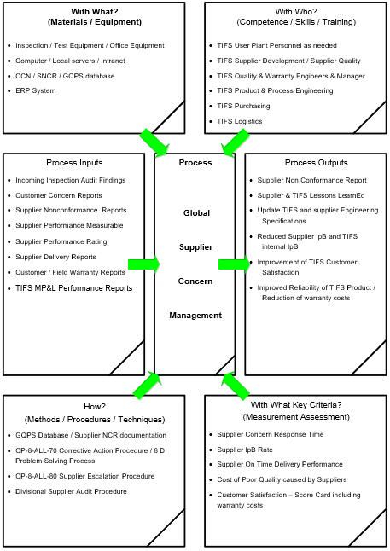
REVISION  LETTER | REVISION  DATE | DESCRIPTION OF CHANGE | APPROVAL  HISTORY
A | 16AUG2010 | Release of new global procedure into the Corporate Quality System. | J. Phillion
B | 20FEB2012 | Changed procedure number to match new corporate scheme: From: GQPS-30-12 to CF-30-ALL-21 | J. Phillion
C | 15OCT2012 | Added criteria for Quality, Delivery, Warranty and PPAP concerns | J. Phillion
D | 31MAR2016 | Review by Purchasing Core team:  Modified the approvers | Global Corporate Purchasing Director*
E | 7th March 2018 | Modified to align with IATF 16949. Change document number from CP-30-ALL-21 to CP-8-ALL-46 | Director Corporate Quality Systems
F | 9th April 2019 | Removed reference to CP-8-ALL-47 Supplier PPAP Procedure | Director Corporate Quality Systems
G | 18th May 2021 | Updated header with new Logo  TI Fluid Systems / TIFS was TI Automotive / TI multiple locations  - Added Logistic  2.5 Added Logistic  3.1 Added definitions: CSCC and 8D / PPS  3.2.3 Added critical concern impact table.  3.5.3 Added 8D Problem Solving Methodology  4.4 Added Supplier Escalation Procedure CP-8-ALL-80  5.8 IpB – Incidents per Billion was PPM  5.12.2.1, 5.12.2.2, 5.12.2.3 Added to Controlled Shipping Level 2 (CS2)  5.14 Turtle Diagram:  With Who: Added Supplier Development and Logistic  Process Inputs: TIFS MP&L was TI MP&L  How: Added CP-8-ALL-80 Supplier Escalation Procedure  With What: IpB was PPM  Process Outputs: IpB was PPM | Director Corporate Quality Systems
H | 26th August 2021 | 5.8.3 Added Concern Ranking Impact table  5.8.3 In example Impact Factor was Concern Ranking | Director Corporate Quality Systems
- REASON FOR CHANGE TABLE:

